**Kocaeli University, Electronics and Telecommunications Engineering Department**

**Digital Communications Laboratory**

**Experiment 3: Line Coding – Simulink Lab Report (11.03.2024)**

|  |
| --- |
| Name-Surname-Number: **Altar Hatipoğlu** |
| Name-Surname-Number: **Fatih Selim Erdeniz** |
| Name-Surname-Number: **Efe Eren Azman** |

**PART A. LINE CODING**

Construct below block diagram in Simulink. Set block parameters appropriately in order to generate **UNIPOLAR** line coding scenarios in Table 1 (“Bernoulli Binary” block generates only unipolar random data)

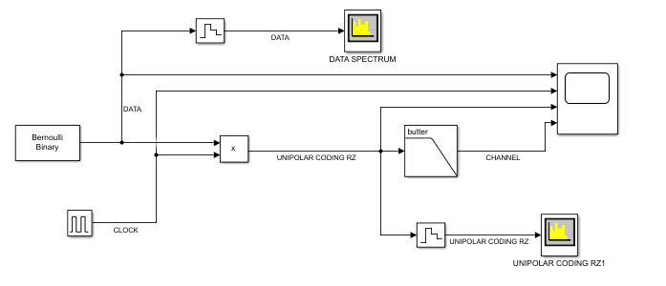

**Table-1**

|  |  |
| --- | --- |
| **Parameter** | **Value** |
| Line Coding | Unipolar RZ |
|  | , 3000 bps |
| Vp | 5V,10V |
| Duty Cycle ( | %50, %75, %100* |

*\*Can be considered as NRZ*

**Q1)** How does changing one of the parameters given in Table 1 (, *Vp* and *Duty Cycle*) effects the bandwidth and power of frequency spectrum.

**DC-güç ile doğru orantılı,**

**DC-Duty Cycle ile ters orantılı.**

Set block parameters appropriately to generate **POLAR** line coding scenarios in Table 2 (To generate POLAR line coding we used “Unipolar to Bipolar Converter” block just after “Bernoulli Binary” block in order to convert unipolar to polar).

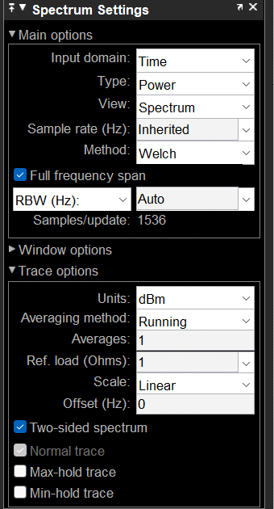**Table-2**

|  |  |
| --- | --- |
| **Parameter** | **Value** |
| Line Coding | Polar RZ |
|  | , 3000 bps |
| Vp | 5V,10V |
| Duty Cycle | %50, %75, %100* |

*\*Can be considered as NRZ*

**Q2)** Run the code for 10 secs. Observe spectrum analyzer outputs for each polar NRZ and unipolar NRZ signals. Do they have included any DC component? Which one has greater DC values? Explain it.

**İkisinde de DC var. NRZ DC>RZ DC. NRZ’da 1 bitin sinyal seviyesi, RZ’ya göre uzun süre boyunca sabit kalabileceği için, bu durumda toplamda daha büyük bir ortalama DC bileşeni görmüş oluruz.**

**For frequency spectrum representation use the parameter set in the right figure.**

**Q3)** Copy and paste scope and spectrum analyzer outputs to the given spaces below.

|  |  |
| --- | --- |
| Polar RZ, %50 duty cycle, Vp=5V, **Rb=1 [kbps]**  Run the code for 5 secs | Polar RZ, %50 duty cycle, Vp=5V, **Rb=3 [kbps]**  Run the code for 5 secs |
| Scope OUTPUT1 for 5 bit times | Scope OUTPUT2 for 5 bit times |
| Spectrum analyzer OUTPUT1 (Y-axis: Power [dBm]) | Spectrum analyzer OUTPUT2 (Y-axis: Power [dBm]) |

**Q4)** Based on your answer to Q3, Comment on differences on BW, power consumption and data rate.

**NRZ----> BW=rb ----->P olsun.**

**RZ-----> BW=2rb------>P/2 olur.**

**Q5)** Copy and paste scope and spectrum analyzer outputs to the given spaces below.

|  |  |
| --- | --- |
| Polar RZ**, %50 duty cycle**, Vp=5V, Rb=1 [kbps] | Polar RZ, **%75 duty cycle**, Vp=5V, Rb=1 [kbps] |
| Scope OUTPUT1 for 5 bit times | Scope OUTPUT2 for 5 bit times |
| Spectrum analyzer OUTPUT1 (Y-axis: Power [dBm]) | Spectrum analyzer OUTPUT2 (Y-axis: Power [dBm]) |

**Q6)** Based on your answer to Q5; Comment on BW, power consumption and data rate differences on outputs’ scope and spectrum.

to ++++ -->-> BW azaldı %50 ye göre yani güç arttı.

**Q7)** According to your observations, fill the table below. Blue arrow stands for causal (cause and result) relationship. Select only the true item(s) and delete the others.

|  |  |  |
| --- | --- | --- |
| Increase in data rate |  | *BW increase* |
| Increase in duty cycle |  | *BW decrease* |
| Increase in duty cycle |  | *data rate decrease* |
| Decrease in duty cycle |  | *data rate increase* |
| Decrease in duty cycle |  | *BW increase* |
| Decrease in data rate |  | *BW increase / BW decrease / None* |
| Increase in duty cycle |  | *Power consumption increase* |
| DC presence in line coding | In terms of error rate | *disadvantage* |
| Time synchronization information | Present in | *both* |

**PART B. INTER SYMBOL INTERFERENCE**

**Q8)** Model the *communication channel* as a Low Pass Filter (Use butter block in Simulink). Change the cutoff frequency between 1 kHz and 10 kHz to fill the table below by copying & pasting filter outputs.

|  |  |
| --- | --- |
| **LINE CODED DATA** | **Scope outputs** |
| Scope filter output for fc=1kHz | Copy & paste scope output for 8 bit times |
| Scope filter output for fc=5kHz | Copy & paste scope output for 8 bit times |
| Scope filter output for fc=10kHz | Copy & paste scope output for 8 bit times |